**Basic Programming**

1. What is the data-type usually used in arithmetic operation?

|  |  |
| --- | --- |
| **Operation** | **Operator** |
| Addition | + |
| Subtraction | - |
| Multiplication | * |
| Eksponen | ** |
| Divide | / |
| Modulus | % |
| Increment | ++ |
| Decrement | -- |

1. What data types are usually used in word and character?

|  |  |
| --- | --- |
| **Word and Character** | |
| Integer | Byte |
|  | Short |
|  | Int |
|  | Long |
| Floating Point | Float |
|  | Double |
| Char |  |
| Boolean |  |

1. The output code is: **113**

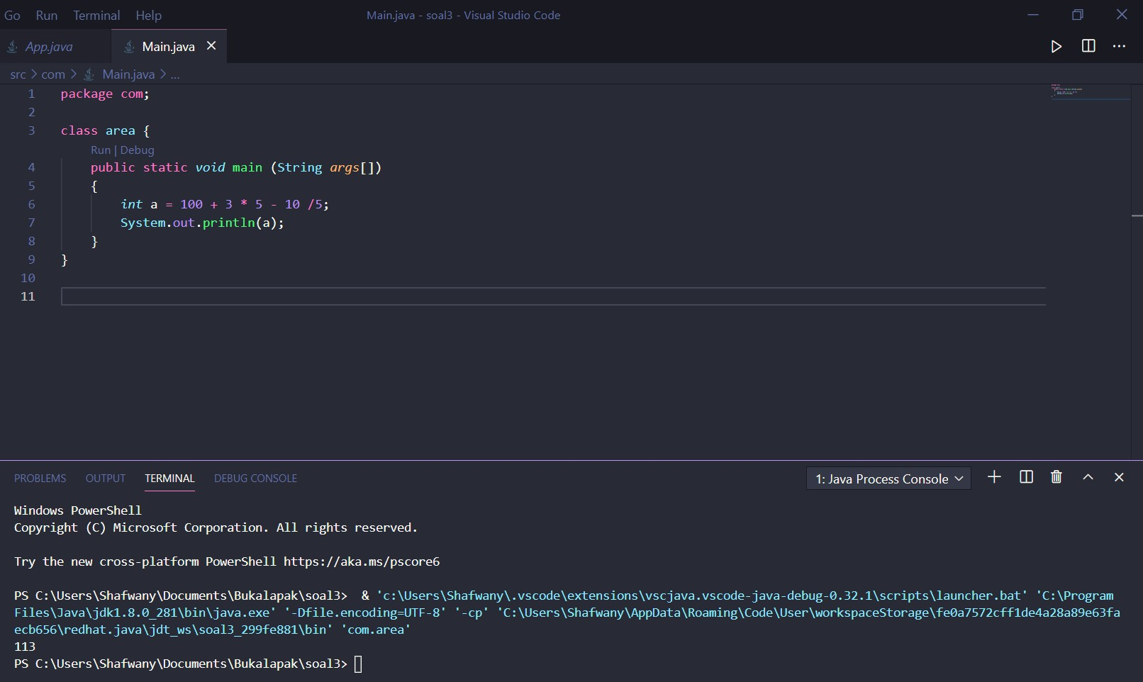

1. The output code is: **2**

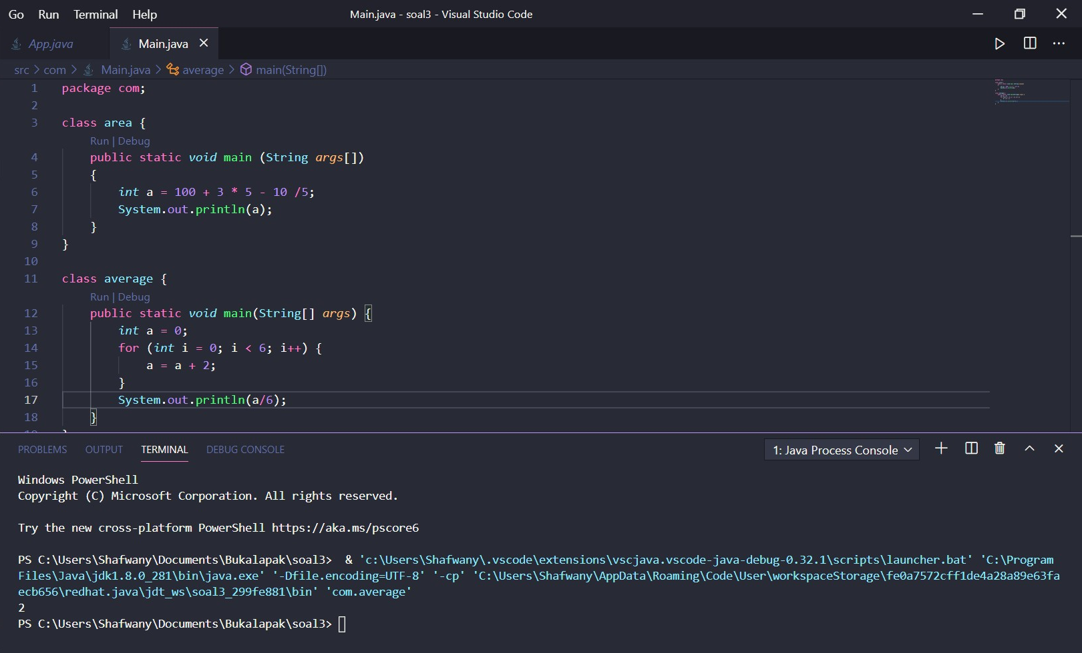

1. The output code is: **3566GoldenStreetMiami**

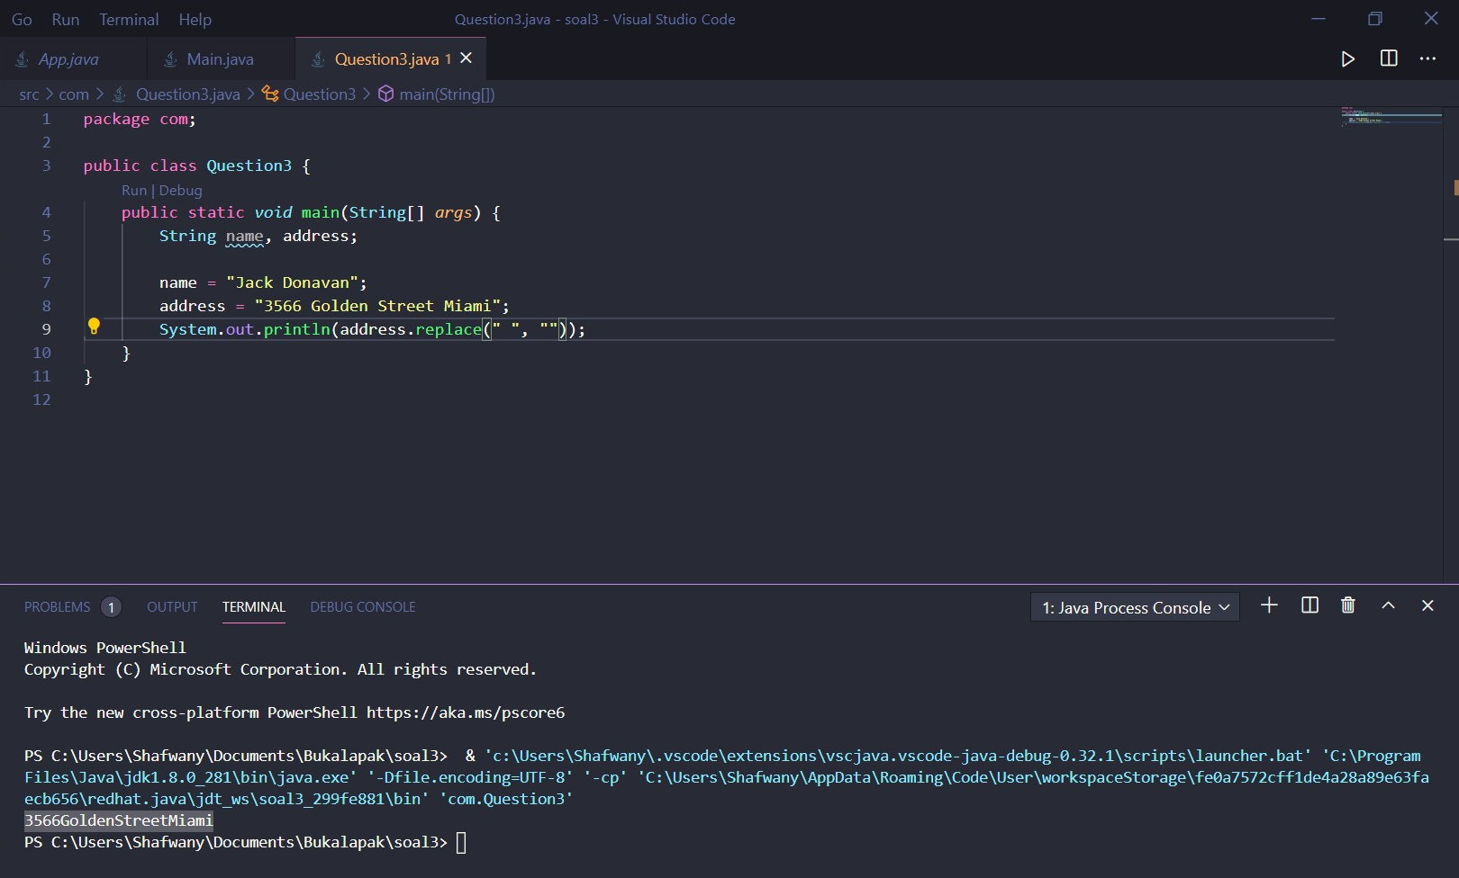

**Flaky Test**

1. What is a flaky test?

The "Flaky Test" is a test that is performed to analyze a program that is run continuously without any code changes but the test gives different results.

1. What do you do to test that element?

I will use QUnit to test the javascript code. QUnit is a powerful javascript unit testing framework that helps a programmer to debug code

1. A website page can only be accessed with CAPTCHA. How do you test that page?

* CAPTCHA is present on the page.
* CAPTCHA field should be required for every login action.
* CAPTCHA code should not be repeated.
* CAPTCHA should not be copyable by mouse/selection.
* CAPTCHA should be changed if the page is refreshed.
* New CAPTCHA should be generated if the wrong CAPTCHA was entered by user.
* CAPTCHA can be case sensitive (According to requirement).
* CAPTCHA should be readable/visible by human.
* CAPTCHA should be displayed completely. Not cut by sides.
* User's IP should be blocked by website if incorrect captcha submission attempts is reached.

**Essay Question Topic**

1. Create automation test script to test these end-point:
2. GET -> <https://jsonplaceholder.typicode.com/posts>:

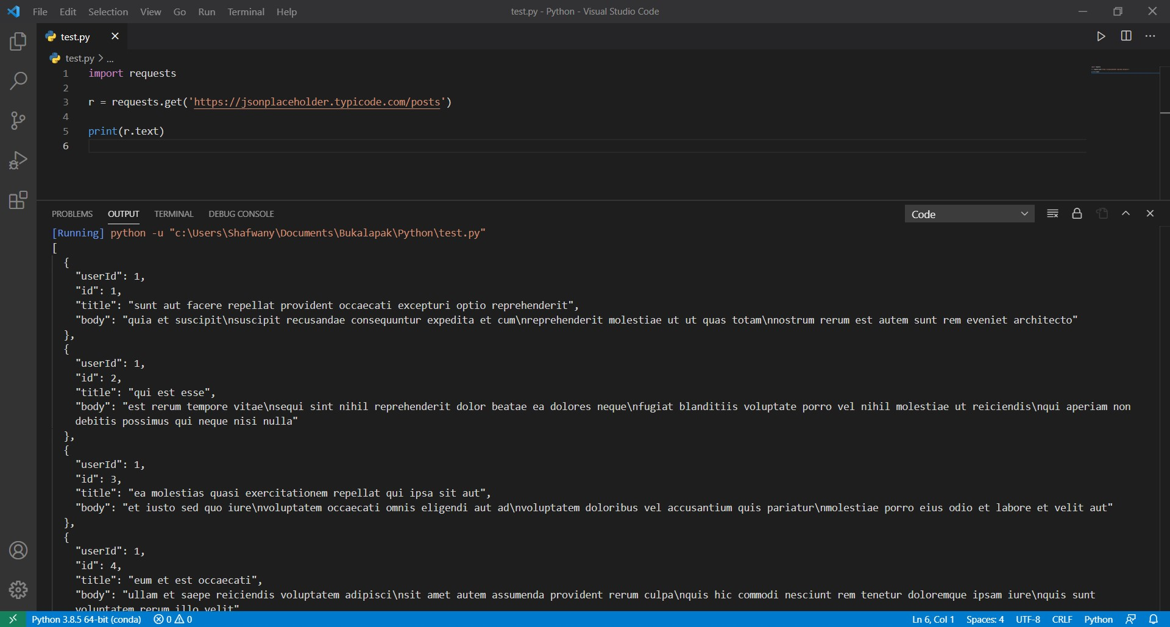

1. POST -> <https://jsonplaceholder.typicode.com/posts>:

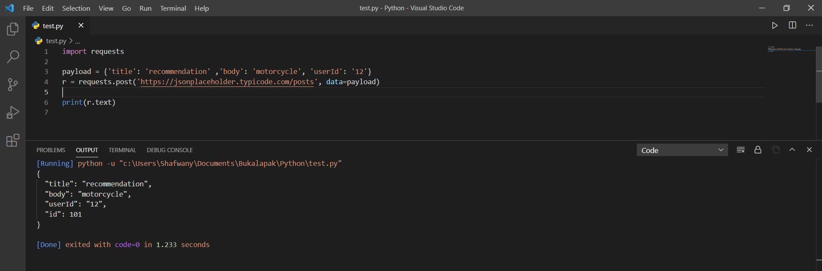

1. Test scenario
2. Register

The system banned my IP Address

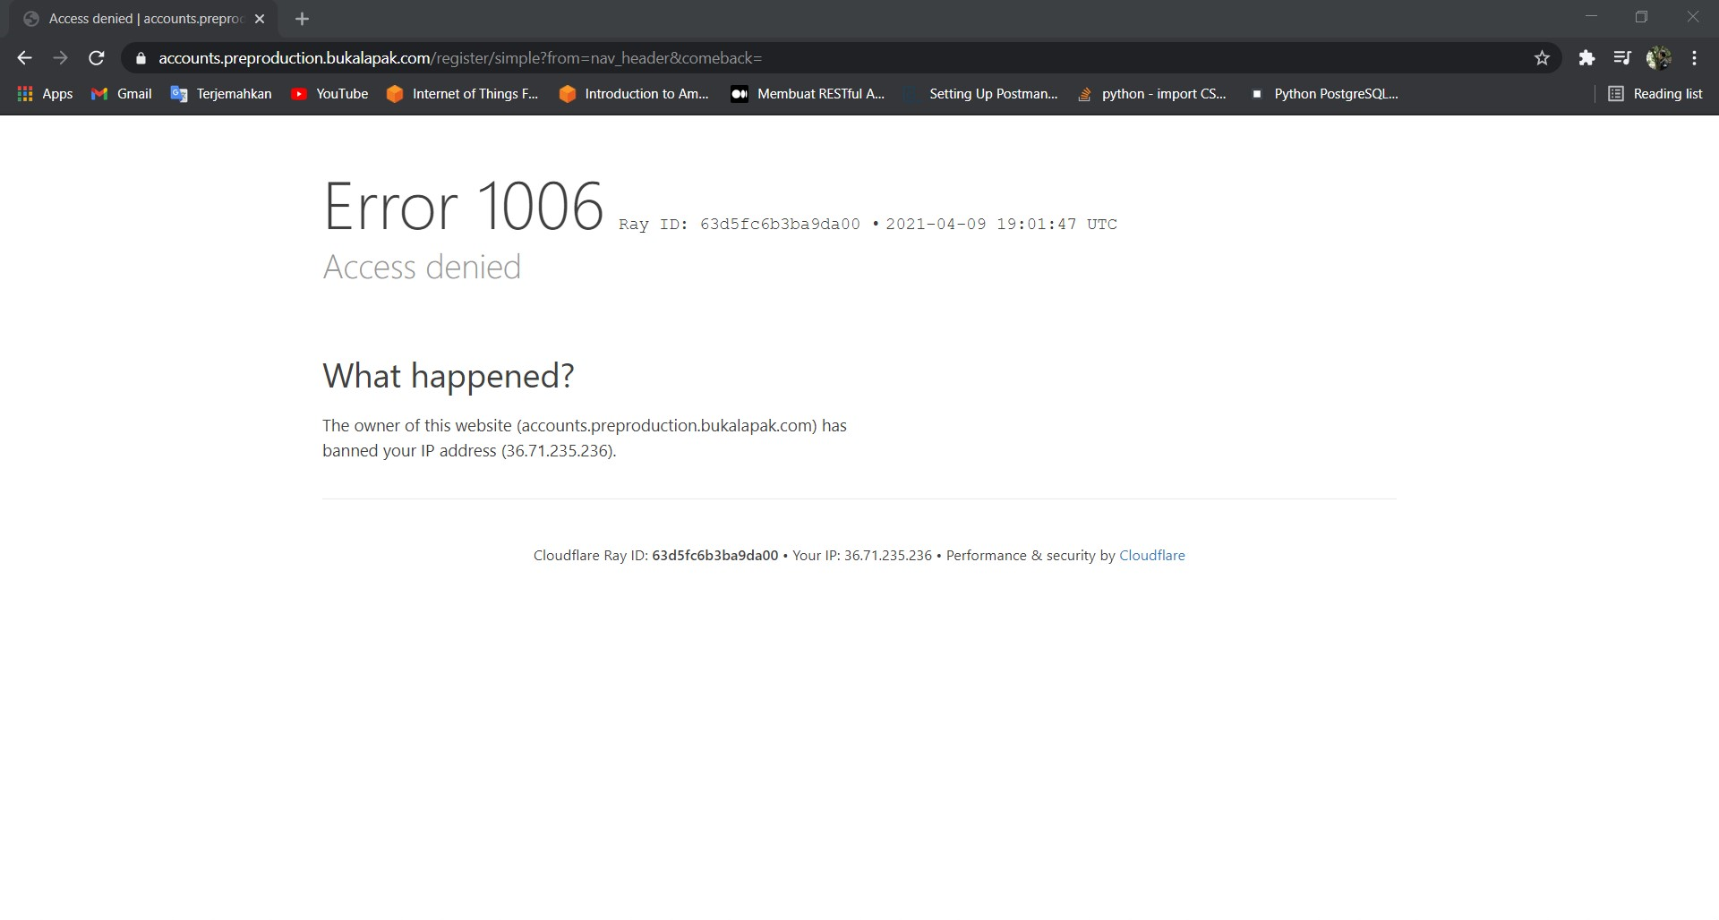

1. Login:

Failed, because I can’t find Button Id.

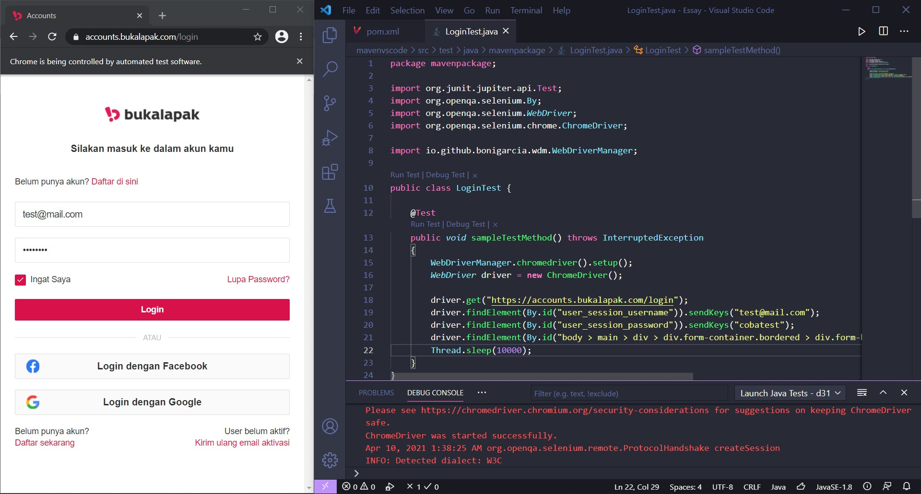

1. Add to Cart

I can’t find Button Id.

1. Search Product

Can’t Searching.

